Work Report 31 july 2021

Firstly I was trying to get the reason why traffic light Map was given nan. I was trying to understand but does not get any specific reason. I think it might be because of the error in writing the class name like **traffic light or traffic_light.** I am trying to figure out this but not successful yet.

Secondly I was going to check on yolo v4. So I was converting coco to yolo.

I have done airplane class after for every class I get the error.

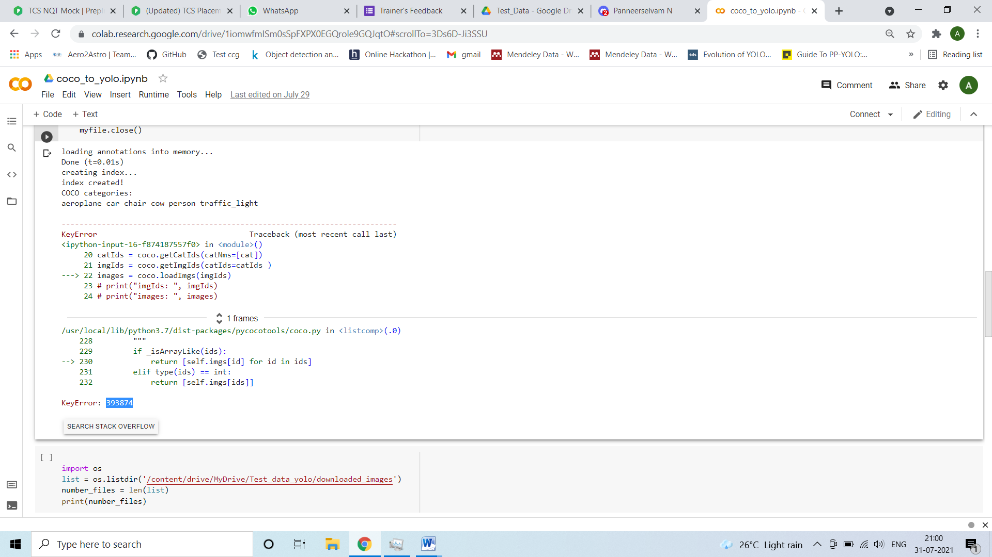

SO I am trying to solve this.